**CLUSTER QUESTION PAPER -set 1**

**CLASS XII**

**BIOLOGY (044)**

Maximum Marks: 70 Time: 3 hours

General Instructions:

1. *All questions are compulsory.*
2. *The question paper has five sections and 33 questions. All questions are compulsory.*
3. *Section–A has 16 questions of 1 mark each; Section–B has 5 questions of 2 marks each; Section– C has 7 questions of 3 marks each; Section– D has 2 case-based questions of 4 marks each; and Section–E has 3 questions of 5 marks each.*
4. *There is no overall choice. However, internal choices have been provided in some questions. A student has to attempt only one of the alternatives in such questions.*

*Wherever necessary, neat and properly labeled diagrams should be drawn.*

**Section A**

1.Which connective tissue surrounds the testis?

(a) Fibrous tissue

(b) Spongy connective tissue

(c) Tunica albuginea

(d) None of them

2.What is the reason for the popularity of the barrier method of family planning?

(a) The absence of side effect

(b) Comparatively more reliable

(c) Protection from sexually transmitted diseases.

(d) Both a and b

3.**The length of DNA molecule greatly exceeds the dimensions of the nucleus in eukaryotic cells. How is the DNA accommodated?**

(a) super-coiling in nucleosomes

(b) DNase digestion

(c) through the elimination of repetitive DNA

(d) deletion of non-essential genes

4.Which of the following is not a source of variation in a population?

(a) Inherited genetic differences

(b) Differences due to health

(c) Differences due to age

(d) None of the above

5.What type of barrier does saliva in the mouth and tears from the eyes belong to under innate immunity?

(a) Cytokine barriers

(b) Cellular barriers

(c) Physiological barriers

(d) Physical barriers

6.Patients can be diagnosed by observing their symptoms. Which group of symptoms indicate pneumonia?

(a) Difficulty in respiration, fever, chills, cough and headache

(b) Constipation, abdominal pain, cramps and blood clots

(c) Nasal congestion and discharge, cough, sore throat and headache.

(d) High fever, weakness, stomach pain, loss of appetite and constipation.

7.What is a free-living nitrogen-fixing cyanobacterium that forms a symbiotic association with the water fern Azolla?

(a) Anabaena

(b) Tolypothrix

(c) Chlorella

(d) Nostoc

8.Suppose an electrical current has moved DNA fragments through a gel. What does the band on this gel that is furthest from the top (that is, from where the DNA fragments were added) represent?

(a) shortest fragments of DNA

(b) longest fragments of DNA

(c) restriction enzyme used to cut the DNA into fragments

(d) ligase used to bind the DNA fragments together

9.In which of the following cases are an organism and its kind of association a matching pair?

(a) Shark and suckerfish – Epiphytism

(b) Algae and fungi in lichens – Mutualism

(c) Orchids growing on trees – Parasitism

(d) Cuscuta (dodder) growing on other – flowering plants –**Commensalism**

10.Species whose populations have been severely depleted and their ultimate survival is uncertain are known as?

(a) Threatened species

(b) Endangered species

(c) Vulnerable species

(d) Rare species

11. Trophic levels are formed by :  
(a) plants  
(b) animals  
(c) organisms linked in food chain  
(d) carnivores

12. What is the primary reason for the decrease in species diversity in tropical countries?

(a) Urbanisation

(b) Pollution

(c) Deforestation

(d) Soil erosion

**Question No. 13 to 16 consist of two statements – Assertion (A) and Reason (R). Answer these questions selecting the appropriate option given below:**

**A. Both A and R are true and R is the correct explanation of A.**

**B. Both A and R are true and R is not the correct explanation of A.**

**C. A is true but R is false.**

**D. A is False but R is true.**

13.**Assertion :**Chasmogamous flowers require pollinating agents.  
**Reason :**Cleistogamous flowers do not expose their sex organs’

14. Assertion : Cross of F1 individual with recessive homozygous parent is test cross.  
Reason : No recessive individual are obtained in the monohybrid test cross progeny.

15. Assertion : Transgenic plant is a product of plant tissue culture.  
Reason : An organism that contains and expresses a **transgene is called**transgenic organism.

16. Assertion : Leaf butterfly and stick insect show mimicry to dodge their enemies.  
Reason : Mimicry is a method to acquire body colour blending with the surroundings

**Section B**

17.Observe the diagram given below and name the parts labelled A, B,C,D.

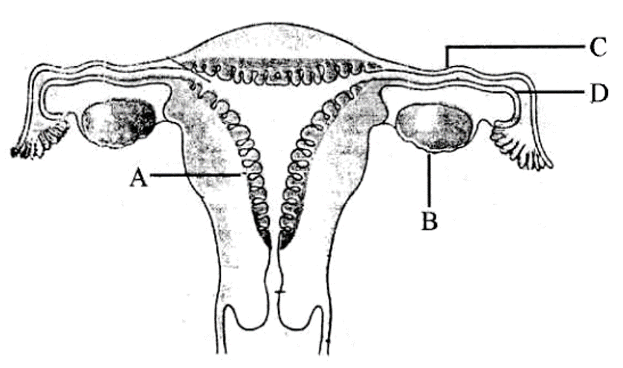

18. In Snapdragon, a cross between true-breeding red-flowered (RR) plants and true-breeding white-flowered **(rr)** plants showed a progeny of plants with all pink flowers.  
i) The appearance of pink flowers is not known as blending. Why?

(ii) What is this phenomenon known as?

19.**Name an allergen and write the response of human body when exposed to it .**  
20.**(i) Illustrate the recognition sequence of Eco RI and mention what such sequences are called?**  
**(ii) How does restriction endonuclease act on a DNA molecule?**

**21**.Why the pyramid of energy is always upright? Explain.

Or

Identify the type of given ecological pyramid and give one example each of pyramid of number and pyramid of biomass in such cases.

|  |  |  |
| --- | --- | --- |
|  | | |
|  |

**Section C**

22.Give the names and functions of the hormones involved in the process of spermatogenesis. Write the names of the endocrine glands from where they are released.

23. Discuss the role of predators in an ecosystem.

24.**Mention the three steps involved in each cycle of Polymerase Chain Reaction (PCR). How is repeated amplification of DNA made possible using PCR?**.

25. (i) Explain adaptive radiation with the help of suitable example.  
(ii) Give an example where more than one adaptive radiation have occurred in an isolated geographical area.  
26. (i) Highlight the role of thymus as a lymphoid organs.  
(ii) Name the cells that are released from the above mentioned gland. Mention, how they help in immunity?   
 Or

Name the parasite that causes filariasis in humans. Mention its two diagnostic symptoms. How is this transmitted to others?

27. Mention any three purposes for which these trangenic animals are produced

28. (a) “India has greater ecosystem diversity than Norway.” Do you agree with the statement ? Give reasons in support of your answer.

(b)Write the difference between genetic biodiversity and species biodiversity that exists at all the levels of biological organisation.

**Section D**

29. During a study on the inheritance of two genes, the teacher asked students to perform an experiment. The students crossed white-eyed, yellow-bodied female Drosophila with a red-eyed, brown-bodied male Drosophila (i.e., wild). They observed that progenies in F2 generation had 1.3 percent recombinants and 98.7 percent parental type combinations. The experimental cross with results is shown in the given figure.

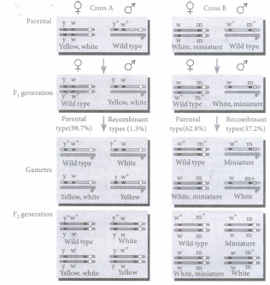  
(i) By conducting the given experiment, the teacher can conclude that  
A. Genes for eye color and body color are linked  
B. Genes for eye color and body color show complete linkage  
C. Linked genes remain together and are inherited

**(a) A and B only (b) B only (c) A and C only (d) A, Band C**

(ii) Why Teacher asked to conduct an experiment on Drosophila .Give any two reason.

(iii) Genes white-eyed and yellow-bodied located very close to one another on the same chromosome tend to be transmitted together and are called

**(a) allelomorphs (b) identical genes (c) linked genes (d) recessive genes**

**(iv) When is the Percentage of crossing over is more**

Or

why Mendel did not recognize linkage phenomenon in his experiments

30. In a study to test a new vaccine against a viral disease, mouse model testing is done. In this process, mice are vaccinated and their blood samples were tested. Mice developed mild disease symptom. After few days those mice were again infected with the virus. This time they do not show any disease symptoms. Their blood samples were tested. Two graphs show antibody concentration for the first and second infection in mice blood.

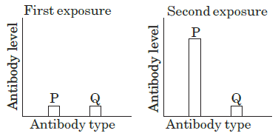

Based on the above information, answer the following questions.

(i) P and Q in the given graphs indicate_____  
(ii) Which form of pathogen is used in vaccination?

(iii)Name the immunogloblin cross the placenta from mother to fetus?  
(iv) How does vaccination work?  
 or

1. How do cytokine barriers provide immunity in humans?

**Section E**

31. (a) Describe any two devices in a flowering plant which prevent both autogamy and geitonogamy.

(b) Explain the events upto double fertilisation after the pollen tube enters one of the synergids in an ovule of an angiosperm.

OR

1. Explain menstrual cycle in human females.
2. How can the scientific understanding of the menstrual cycle of human females help as a contraceptive measure ?

32. Explain the genetic basis of blood grouping in human population.

OR

1. State the ‘Central dogma’ as proposed by Francis Crick. Are there any exceptions to it ? Support your answer with a reason and an example.

b)Explain how the biochemical characterisation (nature) of ‘Transforming Principle’ was determined, which was not defined from Griffith’s experiments.

33.A mention the role of (i) selectable marker, (ii) Ori and (iii) rop in E. coli cloning vector pBR322.

b.Explain the roles of the following with the help of an example each in recombinant DNA technology:

i)Restriction Enzymes ii)Plasmids

or

a) Biological control of diseases and pests to the use of chemicals for the same purpose. Justify.

b)Give an example of a bacterium, a fungus and an insect that are used as biocontrol agents.

_______________________________________________________________________